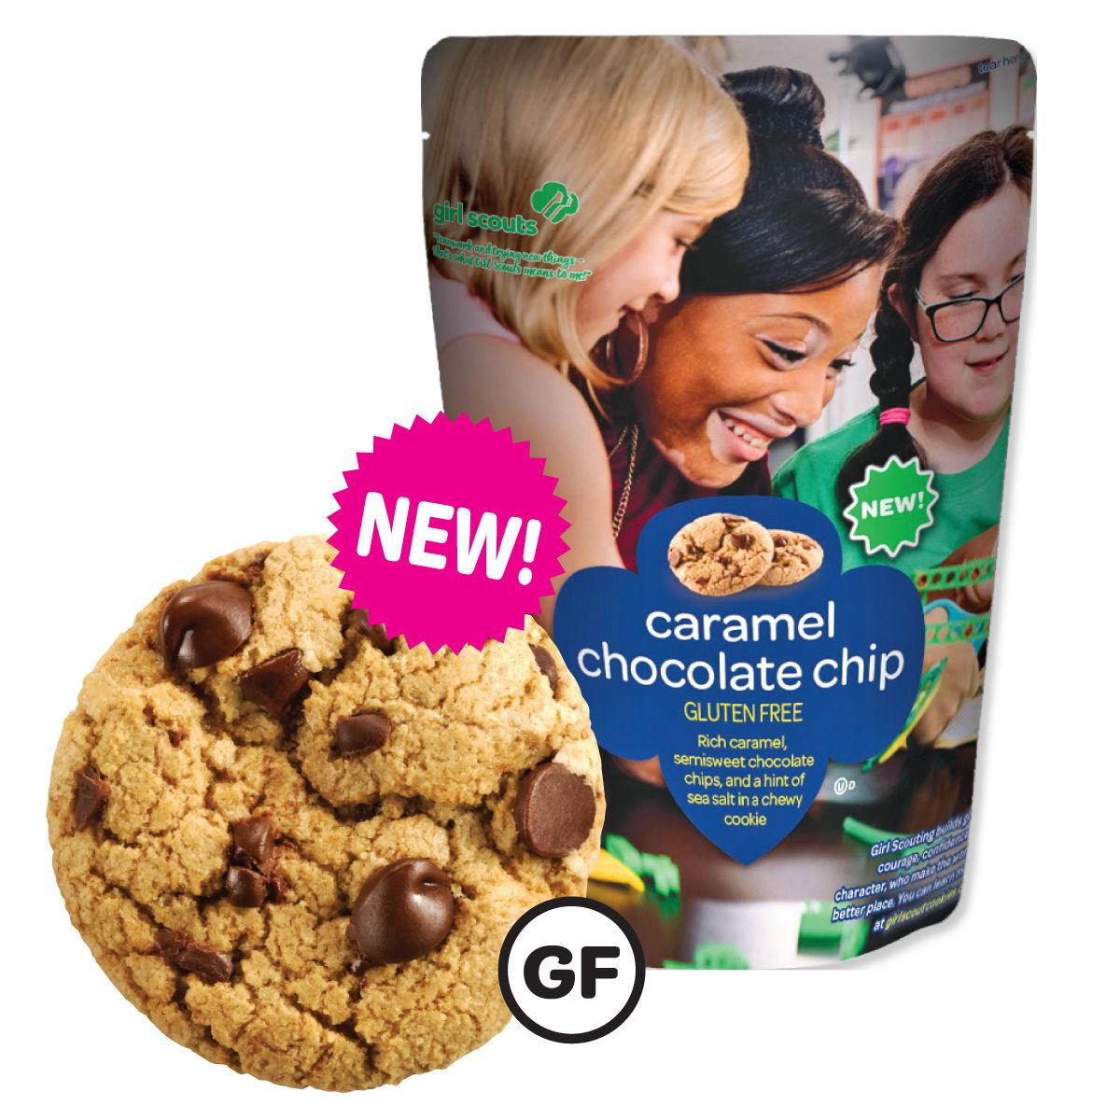



*Made with real chocolate

*Re-sealable pouch

*Order by case (12 per case)

*$6.00 per package
Service Unit: |  |  |  |  |  | Troop #
Leader Name: |  |  |  |  |  | Phone#
Email Address:
# of Gluten Free - Caramel Chocolate Chip cases needed
X
Signature acknowledges troop mentioned above is financially responsible
Reminder this one-time order will be delivered along with your initial order and will be entered by GSESC Product Program Sales Department.
Must be emailed to deborahpaisley@girlscoutsesc.org

***Deadline October 18, 2024***

