Troop Number: ____________________ Service Unit: _______________

Troop Fall Program Manager: _________________________ Phone Number :(_____) ____________________

Email:__________________________________________________________________________________________

Troop Fall Program Manager Login: _______________________ Password: ____________________________

|  |  |
| --- | --- |
| Deborah Paisley, Product Program Specialist  843.300.0063  [deborahpaisley@girlscoutsesc.org](mailto:deborahpaisley@girlscoutsesc.org) | Ashley Barefield, Girl Program Specialist  843.300.0261  [ashleybarefield@girlscoutsesc.org](mailto:ashleybarefield@girlscoutsesc.org) |

|  |  |
| --- | --- |
| **Online Resources**  [www.gsesc.org](http://www.gsesc.org)  Girl Scouts Eastern South Carolina  Forms and Training Materials  800.372.8520  M2 Media Customer Service Number for Magazine Questions  girlscoutmagazines.com/gsesc  M2 Media website  Create avatar and setup store front | **Mark Your Calendar!**   * August – Complete Troop Fall Sale Training * Sept 14 – Fall Sale officially begins – online/order card taking * Oct 13 – Order card taking Sale Ends * Oct 14 – Troop Orders need to be finalized * Nov 4 – Nov 9 Nut/candy order delivered to your SU Product Program Coordinator * Nov 1 – Online Sales End * Nov 25 – Girl money due to troop * Nov 25 – Discrepancy reports due * Dec 6 – ACH money due to council |

|  |  |
| --- | --- |
| **Nuts & Chocolates with Ashdon Farms**   * Our council has collaborated with Ashdon Farms to offer delicious nut & chocolate items this year and more online! * All items make wonderful gifts for teachers, bus drivers… anyone and everyone! * Girls take orders using the nut order taker and can also email family and friends to purchase nut and chocolate items online * Excellent quality and great value = Products that sell themselves * Girls earn special rewards for online sales | **Magazines with M2 Media**   * Friends and family can order/renew their favorite magazines from our online ordering site * Send emails to family and friends inviting them to support your Girl Scouts and council * Visit girlscoutsmagazines.com/gsesc to get started * M2 now has all Time magazines and is offering educational kits * Avatar patches, fun, interactive and easy for girls, parents, and volunteers |

**Troops will earn 15% of the total dollars sold!**

**To participate troops must turn in their Annual 2023-2024 Finance Report.**

**\*Remember Troops OR Any Parents with outstanding balances cannot participate in any council Product Programs \***

**New this year!**

**Send 18+ emails AND sell 1 item in person or online and receive you 2024 Avatar Patch**

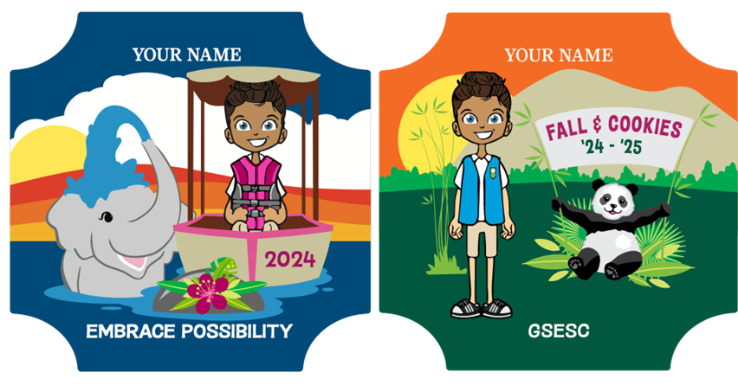

|  |
| --- |
| **Don’t Forget**   * Deposit payments for Fall Sale into your troop checking account quickly to ensure payments will clear. * Order the exact number of nut/chocolate items needed to fill orders. Products cannot be returned to troop or council. * Make receipts for all transactions, including products and money.   **Checklist of What to Turn In**   * Turn in signed Position Description and ACH Authorization forms to receive Fall Program packet. * Log into M2 system and familiarize yourself with system. Set up troop and girl information. * Confirm that each girl participating is a registered Girl Scout for the 2024-2025 membership year. * Hold a troop meeting to train girls and parents on Fall Product Program. Meeting should include:   + Review of all Fall Product materials (order cards, nut products, magazine online program)   + GSUSA safety guidelines for product program in Safety Activity Checkpoints   + Set individual and troop goals   + Share important dates (on order card) On My Honor Date is September 15, 2024   + Complete activities in your Fall Product packet that are age appropriate for your troop.   + Hand out and collect signed parent permission forms for each girl. Handout order card once you have signed parent permission form.   + Explain that there are no returns allowed to the troop or council.   + Review GSESC money handling procedures and check policy. * Collect all order cards from each girl. Make sure girl’s name is on order card. * Enter girl order in M2 by 10pm, October 14, 2024. All troops will be locked out of the system after deadline. * Your SU Product Program Coordinator will notify you when your order is in the week of November 4-9, 2024. Count and sign for **all** items. * Separate each girl’s order and deliver to girls. * Girls deliver and collect money between November 4-11, 2024. Encourage girls to deliver products and turn in money regularly. * Remind girls and parents that chocolate items melt! Melted products are not exchangeable. * By November 25, 2024, you should have collected all money owed from each girl. * If a girl does not pay or if you have an NSF check, fill out a Delinquency/NSF and email it to [jjackson@gsesc.org](mailto:jjackson@gsesc.org) by November 25, 2024.   To view the Fall Product training PowerPoint, go to [www.gsesc.org](http://www.gsesc.org). |

**Checks**

Once a check is received, verify and record the following information on the check: customer’s address, phone number, and driver’s license number. Make sure the checks are made out to “Your Troop Number” and that the written number and amount match. Also, make sure the check is signed and properly dated. Postdated checks are not to be accepted. It is important to inform the customer of the check process. If a check is returned for nonsufficient funds (NSF), you will follow the NSF procedures and the check will be processed by the collections firm.

The council will ONLY cover up to $75 and the bank fees charged to your troop bank account. If a troop incorrectly accepts a check for more than $75 and the check is an NSF check, the council will only be responsible for $75; the troop will be responsible for any amounts over the $75 of an NSF check.

If money and/or product is stolen, a police report needs to be filed immediately and the council needs to be notified. Additionally, the loss needs to be reported to your private insurance carrier. **Ultimately, the individual who lost the money/product is financially responsible for the loss to the council.**

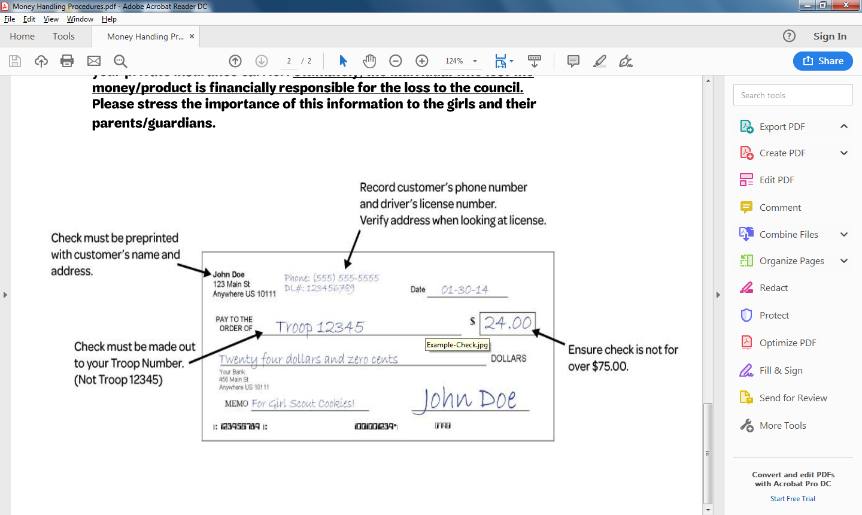Please stress the importance of this information to the girls and their parents/guardians.